**FIS OFFICEMATE**

As the crisis of COVID-19 has wreaked havoc around the world, there will be a day when we will have to live with the virus and come out of this lockdown/Quarantine phase which increases the possibility of spread even more. Businesses facilities are anxious to resume operations following more than two months of lockdown and will need some solid plan to contain the spread and follow the compliance of social distancing.

So, the solution we are suggesting is **FIS** **Office mate** which ensures the safe opening of our IT office and stop further spread while we are in office. This is a web-based application and in future we will be developing the app based and it has multiple features to make life easier once we enter office premises:

* TFR Attendance Management System: Physical Sanitization and Contactless Measures using Devices with touchless temperature measurement and biometrics
* Floor Seating Management: Optimized floor Management to ensure social distancing and limited workforce in the premises
* Cafeteria Ordering: For adhering social distancing, reducing contacts and increasing productivity
* Personal Wellbeing: Psychological Profiling and Suggestive therapy along with fun factors
* Marketplace for and by Employees

Technology/Platform Suggestions: The idea is in nascent phase and we have explored few technological solutions as below:

* IBMs ICLOUD for Webhosting
* IBM Watson Suite
* Python/json for web backend
* Cloud databases on IBM Cloud™ (Mango DB) or Cloudant

FIS Office mate is better compared to multiple market solutions as this is one stop solution offering umbrella of features.

This is adaptable, flexible, scalable for large organizations. Easily customizable.

**TFR Attendance Management system.**

** TFR stands for Temperature Face Recognition.

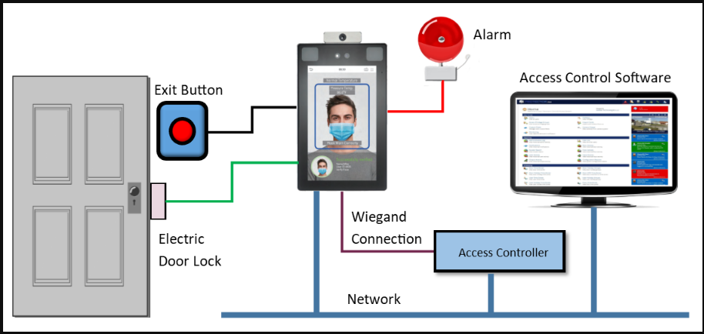

Necessity, according to the proverb, is the mother of invention and while it may be an overstatement to say that COVID-19 created the need for temperature detection software, it certainly fostered the fastest demand for temperature detection in combination with biometric identity verification as organizations scramble for ways to protect guests and employees from airborne pathogens and bacteria.

Businesses facilities are anxious to resume operations following more than two months of lockdown, but they need to enforce social distancing and identify people with high temperatures. In response, to this there is need to develop fully automated identity and temperature monitoring tools that allow locations to check people's temperatures.

We need to team and offer contactless temperature sensing software for medical and HR applications. This solution will sense temperatures from anyone passing through its sensors. Where temperature monitoring equipment usually involves infrared cameras, we can make use of AI technology with deep learning to combine facial recognition and thermal detection to detect persons who have high temperatures as well as those violating requirements to wear masks. Without the AI and deep learning, the surrounding environment can more easily interfere with readings, leading to missed reports and false alarms. When the system detects someone, who has a fever or isn't wearing a mask, it can alert staff, allowing them to locate the person. The software developed should also supports optional functions such as IC non-card access, two-dimensional code, etc., which can be applied to gate passages, access control attendance, visitor registration and access control.

We can use the existing Kiosk in market with price range from 85 thousand to around 1.5 lakhs rupees (One location can have only one machine since such kiosk can scan faces up to 50,000) and integrate those with the existing FIS systems like AMS and security systems – Since it’s a single sign on. Why AMS? This will help us to track who was in office and for what time. And why Security System? This will alert the security personal on duty if any personal has high temperature beyond the threshold set.

How to link it with our existing systems will be somehow complicated. But yes, some idea around this is like –

1. Post face recognition store the attendance data in a DB (Cloud), run a job that will upload the details in AMS, which can be reflected to see in the Office Mate application, or we can integrate AMS to our Office Mate application. The job may run after a scheduled duration.

1. Secondly, Alert the Security/Admin personnel– We can have a replica of the Kiosk screen at the security personal desk. So, in case there is an alert issued for high temperature either it can be a visual/audio using sensors, link it to the screen where the security personal sits. This will enable the security personal to act immediately.

* Since face recognition is already done and employee is detected, the alert message of high temperature can also flow in the same DB (as in case1). The scheduled job that runs can modify the Office Mate portal accordingly. Since Managers need access to Teams data – they should be aware about the employee health situation.
* In case the person is an outsider and not linked to any employee ID, data wont flow to our systems. But the security personal can act accordingly.
* Also, in case the person is a visitor with a temporary badge issued but has high fever, we can provide the records against that badged temporarily issued. This includes cafeteria or housekeeping staff.

Challenges / Solutions –

* Traffic at the Kiosk – This needs to be addressed. Either we can have multiple Kiosk at parking and ground floor, but this will affect the costing. But if Budget is an issue then, we can use one kiosk is used, then social distancing and Hygiene needs to be followed
* Sensor Doors should be available at all floors and Paddle sanitizer at the Door.

Integration of the FIS- Office Mate application with existing system also needs a bit more analysis

**Features of Access Control Reader**

• Face authentication range up to 8 feet

• Stores & matches up to 50,000 face templates

• Stores & matches up to 5,000 palm templates

• Mask detection

• 8-inch touchscreen display

• Intelligent energy-saving design

• Dual lens IR & VL camera recognizes faces in both total darkness and bright sunlight

• Body temperature detection accuracy +/- 0.6 degrees Fahrenheit from up to 2 feet away.

**Optimized Floor Seating Management system.**

**Reopening your office during COVID-19? In this unprecedented time, to ensure the compliance to government’s mandate to have maximum 10% staff in office at any given time we need some smart way to have right amount of people with right skill people in office.**

**So, FIS Office Mate has a smart solution which can:**

* **Protect employees: Under social distancing rules, employees must be kept at least six feet (two meters) apart. For many, this means a complete reorganization of your floor plan**
* **Coordinate shifts and schedules: Taking a shift-based approach in the early stages of the return to work. Smart co-ordination using Office Mate to ensure physical distancing and giving the employee guarantee of proper sanitization of their workstations/seats**
* **Fixed percentage of workforce in office: With the smart algorithm, there is an option to have fixed percentage of people to enter in office and arrange them in such a fashion to adhere social distancing**
* **Flexibility to choose between functions in each BU so that right number of workforces from all streams like Dev/BA/QA/PM are present**
* **Notification of Desk location/Date of office going: Smart notification on App/SMS to confirm your desk location and date of the month 3 days prior**
* **Additionally, if anyone must visit the office due to high priority work few reserve seats will be generate through the algorithm. Say per floor 3 to 5 seats can be kept for visitors or employees with priority work**
* **Pre-requisites:**
* **Office Floor plan**
* **Configurations files which has all the functionals involved in BU**
* **Fixed percentage which can change gradually**
* **Impediments: Checks of sanitization of workstations after every shift.**

**Cafeteria Ordering System**

**Food is one of the most important aspect of daily life. And many of the time cafeteria is the place where we crack some deals, have clear conversations in office over a cup of coffee or while grabbing sandwich.**

**But this must change after COVID-19? So, what you cannot seat together, but you can still grab that sandwich without fearing the contact.**

**FIS Office Mate`s solution of Online Cafeteria Ordering is just what you need:**

* **Flexibility: To choose various options from Menu**
* **Protect employees: Under social distancing rules, it will be difficult to grab lunch/snacks together. So, order online and wait for your order to get ready**
* **Pop up Notification: Get the notification once your order is ready and you can pick it up without contacting anyone**
* **Cashless: Payment options embedded**
* **In case the waiting time is more than expected – Employee can cancel the order.**

**Workplace Wellbeing**

Personalization and control (perceived or actual) over our work and environment are shown to be key drivers of positive mental health and wellbeing, according to a survey by the [Society for Human Resource Management](https://www.shrm.org/hr-today/trends-and-forecasting/research-and-surveys/Documents/2016-Employee-Job-Satisfaction-and-Engagement-Report.pdf)

Following solutions can be provided through our portal/app to help wellbeing check-ins

1. **Moodpath** ( This app is available in the market and can be integrated with the Portal)

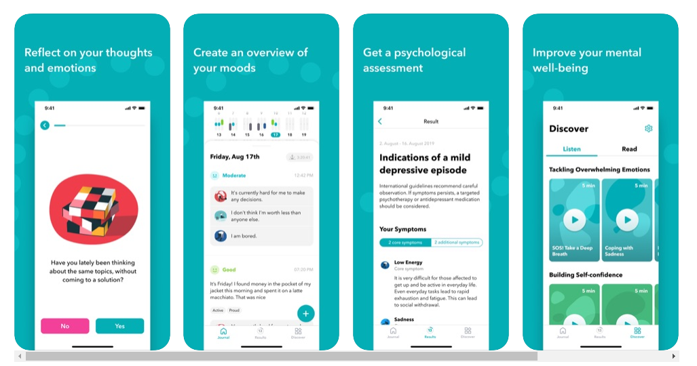

This app helps to improve emotional well-being with a bi-weekly mental health assessment.

Users answer daily questions and track their moods throughout the morning, afternoon, and evening. Based on the answers, they will receive supportive insights to understand unique emotional patterns and triggers better. Moodpath also lets user choose from a library of Cognitive Behavioral Therapy exercises to learn new mindful techniques and self-compassion skills.

* Cost and User load
  + The services of Moodpath are free of charge.
  + Daily 15000to 20000 number of users can use this app.
* Terms and Conditions

<https://mymoodpath.com/en/terms-services/>

1. **Journey Meditation**

Because meditation helps relieve built-up stress and tension, it can help boost employees' decision-making skills. Practicing **mindfulness** teaches the brain to better focus and concentrate on the present moment

Health tips, videos of breathing exercise and other health tips can shared by organization health committee will be available

## **A Meditation You Can Do at Your Desk**

1. Begin by bringing your attention to the sensations of your breath.
2. When you’re ready, direct your attention to the soles of your feet, opening your mind to whatever sensations are there to be noticed.
3. Perhaps you are noticing the pressure on the soles of your feet as the weight of your legs rests on them. Perhaps the soles of your feet feel warm or cool.
4. Just notice. No need to judge or engage in discursive thinking. If your mind is pulled away or wanders, redirect your attention, firmly and gently.
5. Move your attention next to the tops of your feet, ankles, lower legs, knees, and so forth.
6. Gradually scan through your body, noticing sensations, noticing discomfort, and noticing areas of your body where you detect an absence of sensations. No need to search for sensations; just keep scanning through your body, taking your time and being open to what is here.
7. **Coloring books**

Studies show that coloring is a great way to relieve stress. Employees can access this space and unlock multiple options at once. They can choose between an acrylic brush, watercolor brush, or spray can to create work of art. Color inside the lines, zoom in and out to capture details and save masterpiece on the desktop. They can even print the pieces they are extra proud of. Unleash the inner artist and color away stress with this space.



1. Pictionary

Online Pictionary can be integrated with this portal

<https://randomwordgenerator.com/pictionary.php>

1. Online Quiz

A comprehensive quiz bank can be added to this space and can be used by one or multiple employees for Team Building or for individual use.

**Benefits**

* Reduces Stress and Burnout
* Increase Resilience
* Improve Culture and Engagement

**Top challenges:**

1. Searching and uploading meditation videos
2. Making sure productivity is not hampered
3. Maintaining data security for MoodPath

**Solutions/suggestions**

1. Cultural committee can be formed within organization to facilitate this
2. Auto close times can be set to control excess usage of these features and to maintain the productivity at work
3. In order to maintain data security similar app can be developed by FIS employees and can be integrated to this portal.

**Market Channel/Marketplace**

In these times we need to create an ecosystem and partnership and convert store into a platform to enable more deliveries in a day to our employees via ecommerce or phone delivery. This space will be added to provide marketplace from employee to employee.

Open space will be created allowing employees to post buying and selling ideas for home made goods by them or their families/friends with required contact information.

Using this information for buying/selling goods from specified contacts from this space will be a responsibility of individual employee.

Benefits

Making channel available for employee and their families.

Top Challenge

Maintaining hygiene for food items to be sold by employee or their families

Solution/Suggestion

Food making videos of family members can be uploaded to this space to make sure hygiene is maintained during preparation